April 10, 2021

It is a new year, and we are ecstatic to bring back the Parkfield Ranch Rodeo and celebrate the 28th Annual! Due to the current circumstances in the world, we are changing things up a little this year and presenting “The Parkfield Round Up” by Parkfield Ranch Rodeo 2021. We will host a Breakaway, Barrel Racing, and Team Roping jackpot for contestants of all ages. Also, new this year will be a Pasture Team Roping, making sure we stay true to our Ranch Rodeo roots! We would like to present you with opportunity to support our event this coming May! It is with your helpful donation that we will be able to fulfill our goal of making this a fun and successful event. Please join us on this endeavor in bringing back the “good times” after a long, unprecedented year. We would like to give our Rodeo community something fun to look forward to! Attached are the new sponsorship levels for 2021. Feel free to call us with questions or feedback. We also hope you will join us May 29-30th in our sponsor VIP area and take pictures with our champions at the conclusion of the Parkfield Round Up!

Sincerely,
Kayla Santos

And
Sage Massey

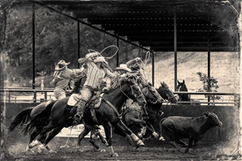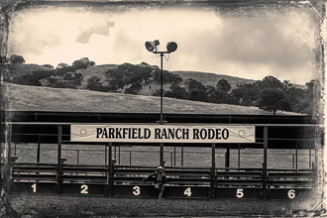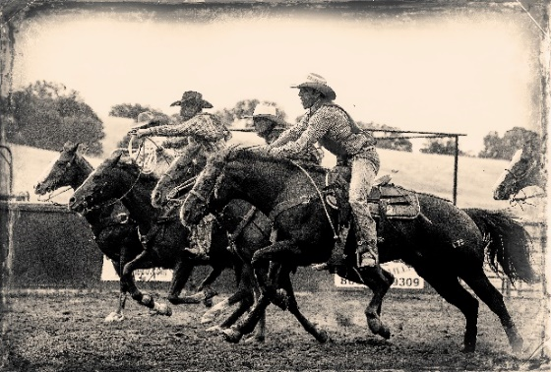
The Cowboy

Donation ranging from $501 - $750
- Arena Sponsor
- Banner inside arena (must provide the banner)
- Receives recognition announcement and advertisement during weekend.
- Your business will be listed on Parkfield Ranch Rodeo website (www.parkfieldranchrodeo.com)
- Social Media shout-outs on Facebook and Instagram with a reach of 30,000 people

Top Hand

Donation of $751+
- Event Sponsors
- Banner inside arena (must provide the banner)
- Receives recognition announcement and advertisement throughout their event.
- Free drink wristbands for 2 people for each day (Saturday & Sunday)
- Free lunch for 2 people for each day
- Your business will be listed on Parkfield Ranch Rodeo website (www.parkfieldranchrodeo.com)
- Social Media shout-outs on Facebook and Instagram – with a reach of 30,000 people

Gifts in Kind
- We graciously accept gifts in kind. Depending on your estimate of your donation we will apply your sponsorship level. Please note our sponsorships work up from $250.
- We hope many of these charitable gifts will serve as awards for our weekend champions.
- Please note what you would like to donate on following page.
Friends of Parkfield Round Up

Donation of $250-$500
- Your business will be listed on Parkfield Ranch Rodeo website (www.parkfieldranchrodeo.com)
- Social Media shout outs on Facebook and Instagram with a reach of 30,000 people
- Banner Space outside of the arena - Grandstand, restrooms, announcer booth, concession stand (must provide the banner)

Mail to |Parkfield Ranch Rodeo| 504 Forest Ave.| Templeton, CA 93465
Please return form by May 10th 2021
Instructions:
- Choose the level donation you would like to make. Fill out the following page and return with check to Parkfield Ranch Rodeo.
- All Sponsors, please send email of artwork you would like featured on social media and website to parkfieldrodeo@gmail.com.
- Top Hand and Cowboy Sponsors, please email us your plug or any information you would like announced over the weekend.
- All Sponsors must provide their own banner.
Name of Sponsor _________________________________________________________________________
Sponsorship Level ________________________________________________________________________
(Top Hand $751+, Cowboy $501-$750, Friends of Parkfield $250-$500)
Sponsorship Amount ________________________________________
Will your team be attending the event? ____________________________
Gift in Kind
Estimated Value $________________________ Description of Gift_______________________________________
________________________________________________________________________________________________
Will gift be (choose one) Mailed _____ Picked up _____ If mailed, please use: 504 Forest Ave. Templeton, CA. 93465
Is there a specific event you would like to Donate to? (Circle one)
Barrels Breakaway Team Roping Pasture Team Roping Unspecified

Contact Info
Please fill out your most convenient contact information below so we can send you any additional information.
Name__________________________________________________
Address ________________________________________________
Town __________________ State _______ Zip ______________
Phone # ________________________________ Email ______________________________________
Social Media handle _____________________________
Reach Us
Sage Massey
805-434-8677 - sagemassey1997@gmail.com

Kayla Santos
805-423-5700 - parkfieldrodeo@gmail.com

